EXP 11

**Demonstrate virtualization by Installing Type -2 Hypervisor in your device, create and configure VM image with a Host Operating system (Either Windows/Linux).**

STEP 1: To create the new virtual machine

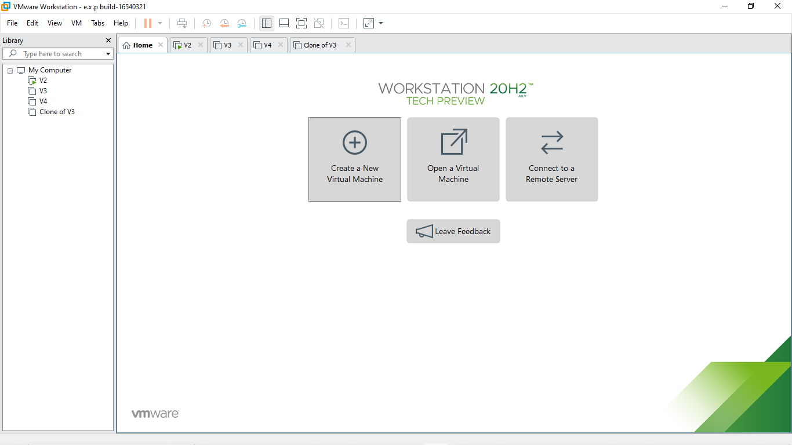

STEP 2: To install the guest operating system and browse it in the installer disc image file

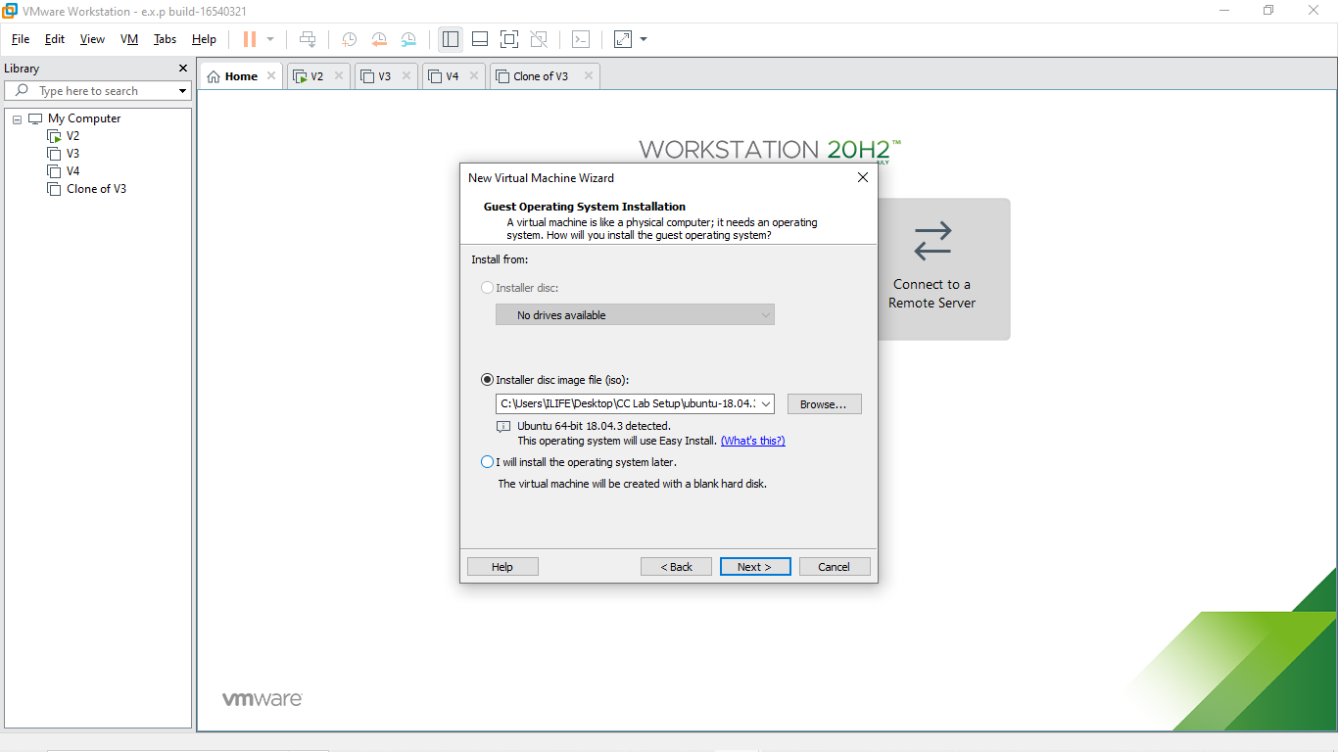

R.Akash 192121091

STEP 3: Name the virtual machine

STEP 4: Give storage to the disk capacity in a single file

R.Akash 192121091

STEP 5: And finally the ubuntu virtual machine is created

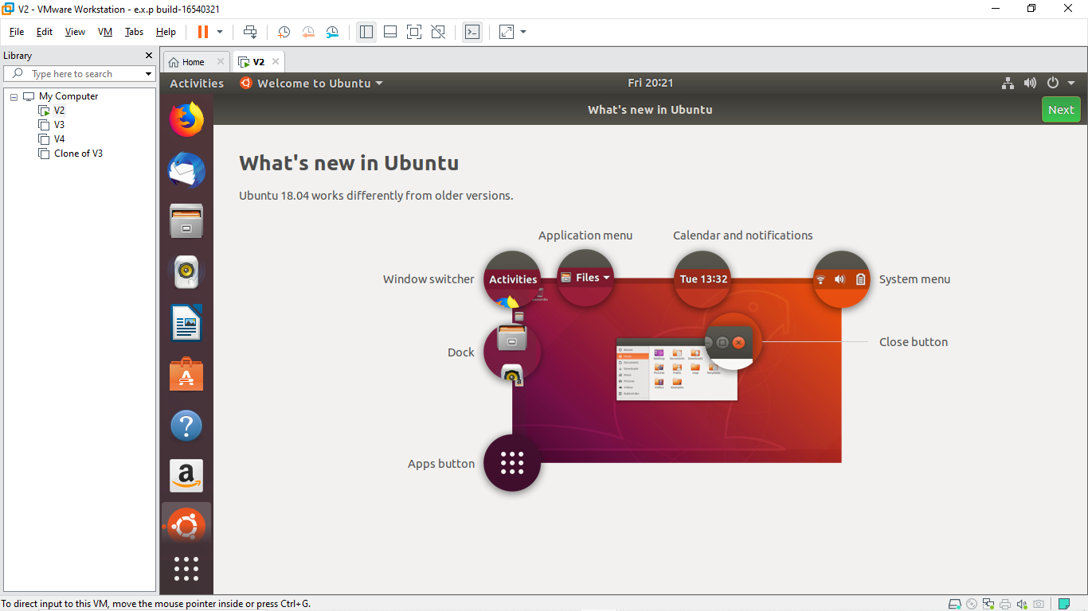

R.Akash 192121091